Automatic Line Marking Robot

|  |  |  |
| --- | --- | --- |
| Kishore C  *Department of ECE*  *PSG Institute of Technology and Applied Research*  Tamilnadu, India  *21124@psgitech.ac.in*  Deepak K  *Department of ECE PSG Institute of Technology and Applied*  *Research*  Tamilnadu, India  *21l109@psgitech.ac.in* | Deepesh M  *Department of ECE*  *PSG Institute of Technology and Applied Research*  Tamilnadu, India  [*21l110@psgitech.ac.in*](mailto:21l110@psgitech.ac.in)  Dr.D.Selvakumar  *Department of ECE*  *PSG Institute of Technology and Applied*  *Research*  Tamilnadu, India  *selvakumar@psgitech.ac.in* | Prasanna Kumar K  *Department of ECE*  *PSG Institute of Technology and Applied Research*  Tamilnadu, India  *21l135@psgitech.ac.in* |

***Abstract*--** **Maintaining sports stadiums, especially ensuring precise court lines, is laborious. Redrawing lines after events poses a significant challenge for maintenance teams. The proposed bot aims to alleviate this burden by autonomously marking linear lines on sports courts, including those for various sports like volleyball, basketball, tennis, and football, as well as track boundaries. Integrating robotics and computer vision technologies, the system detects court boundaries and existing lines using sensors. Navigation algorithms enable the bot to traverse the court while avoiding obstacles, and a precise line drawing mechanism ensures accurate line placement. Rigorous testing in diverse stadium environments validates the bot's performance and reliability. Implementing this autonomous system into maintenance workflows is expected to substantially reduce manual labor and time spent on line marking tasks, enhancing overall efficiency and effectiveness. This advancement not only benefits maintenance staff but also event organizers. Furthermore, there is potential for additional features and improvements to further enhance the system's capabilities and applicability in various scenarios.**

***Keywords: Motor Driver , Rotary Encoder***

# INTRODUCTION

Maintaining stadiums worldwide is a massive undertaking, with approximately 4749 stadiums spread across 224 countries. These stadiums host various sports and events, accommodating audiences exceeding 150,000 spectators. Stadium maintenance encompasses a wide range of tasks, including cleanliness, security, seating arrangements, asset tracking, concession stands, ticket counters, and player facilities, among others. One crucial aspect of stadium upkeep is marking tracks and boundaries on courts, which adds to the aesthetic appeal and functionality of the venue.

Despite the significant workload involved, there has been limited research in the area of autonomous sports track painting. This extends to painting markings on roads as well. The existing literature on sports court painting is scarce and lacks comprehensive solutions. Therefore, this paper aims to introduce the development of an autonomous robot to assist in stadium maintenance tasks, particularly in track painting.

Stadium maintenance staff work diligently to ensure that courts are properly marked and maintained during events, often facing challenges such as adverse weather conditions. The proposed robot aims to alleviate the burden on maintenance staff by autonomously painting track boundaries and layouts according to official requirements for various sports. For instance, the robot would be capable of accurately drawing lines for a square lawn or marking out boundaries for different sports using powdered chalk.The motivation behind this research stems from the increasing trend of automation in various aspects of modern life. Automated machines have proven to be efficient and accurate in tasks requiring speed and precision. Painting tracks, whether on sports courts or roads, is a time-consuming process when done manually. Therefore, automating this task would not only make maintenance easier but also significantly reduce the time and effort required. This research proposes an automated painting bot designed to streamline track painting in sports stadiums, contributing to enhanced efficiency and productivity in stadium maintenance operations.

# LITERATURE SURVEY

Hidayat, Muhammad, Anisah Ulfah Fauziyya, and Syahril Ardi designed a control system for an arm robot used in the automotive manufacturing industry for loading and unloading parts on a marking machine [1]. Khan, B. S., M. Hanafi, and S. Mashohor developed an automated road marking detection system tailored for autonomous cars [2]. Morrissett, Adam, and Sherif Abdelwahed conducted a review on non-lane road marking detection and recognition, [3].Zhao, Kun, Mirko Meuter, Christian Nunn, Dennis Müller, Stefan Müller-Schneiders, and Josef Pauli introduced a novel multi-lane detection and tracking system [4]. Hameed, Ibrahim A., Claus G. Sorrenson, Dionysis Bochtis, and Ole Green discussed field robotics in sports, specifically the automatic generation of guidance lines for automatic grass cutting, striping, and pitch marking of football playing fields [5]. Hameed, Ibrahim A. presented research on path planning for line marking robots using 2D Dubins’ path [6].Mohd Kiblee, Shahizul Eza conducted research on a lane detection system for autonomous vehicles using image processing techniques [7]. M. A. H. Ali, W. A. B. W. Yusoff, Z. B. Hamedon, Z. B. M. Yussof, and M. Mailah developed a mechatronic system for road marks painting [8]. S. Ohno and T. Takimoto developed the Automatic Line Maker robot using laser telemeter technology [9]. S. Kotani, S. Yasutomi, X. Kin, H. Mori, S. Shigihara, and Y. Matsumuro worked on image processing and motion control of a lane mark drawing robot [10].Following are the drawbacks of the existing system which the authors have learned through a literature survey

* Real-world Validation and Performance Evaluation
* Complexity and Reliability Concerns
* Effectiveness Evidence and Empirical Support
* Vulnerability to Unauthorized Access
* Challenges in Technology Integration

# PROPOSED SOLUTION

The line marking robot is a comprehensive solution designed to automate the process of marking lines on sports courts or other surfaces. It features four wheels, each connected to a DC motor, providing stability and precise control over movement. A DC motor driver ensures equal power distribution to each wheel, ensuring consistent movement and accurate line marking.At the heart of the robot is a PIC microcontroller programmed to receive user inputs, such as the type of game or sport being played, and calculate the appropriate court dimensions. This pre-processing of court dimensions ensures precise marking according to specific requirements.To achieve accurate marking, a rotary encoder measures the distance traveled by the robot, providing real-time positional feedback. This allows the microcontroller to adjust movement for precise line placement. The robot employs simple operations to navigate and maneuver, adjusting motor speeds and directions to avoid obstacles. Algorithms may be implemented for smooth turns and precise maneuverability, ensuring accurate marking even on complex surfaces. The marking mechanism, positioned at the end of the robot, can utilize either limestone or paint based on user needs. It effectively deposits the marking substance onto the surface, controlled by mechanical operations. This flexibility allows for temporary or permanent markings, depending on surface type and visibility requirements. Overall, the line marking robot combines mechanical components, electronic hardware, and software programming to automate line marking with precision and efficiency. Its ability to accurately mark lines according to user-defined dimensions makes it an invaluable tool for stadium maintenance and sports facility management.

# HARDWARE REQUIREMENTS

The components used are:

1. PIC Microcontroller (PIC16F887)
2. DC Motor Driver
3. Rotary Encoder
4. DC Motor
5. Battery

*A. PIC Microcontroller ( PIC 16F887 )*

The powerful yet easy-to-program (only 35 single word instructions) CMOS FLASH-based 8-bit microcontroller packs Microchip's powerful PIC® architecture into an 40- or 44-pin package. The PIC16F887 features 256 bytes of EEPROM data memory, self programming, an ICD, 2 Comparators, 14 channels of 10-bit Analog-to-Digital (A/D) converter, 1 capture/compare/PWM and 1 Enhanced capture/compare/PWM functions, a synchronous serial port that can be configured as either 3-wire Serial Peripheral Interface (SPI) or the 2-wire Inter-Integrated Circuit (I²C) bus and an Enhanced Universal Asynchronous Receiver Transmitter (EUSART). All of these features make it ideal for more advanced level A/D applications in automotive, industrial, appliances or consumer applications. This is shown in figure 1. - 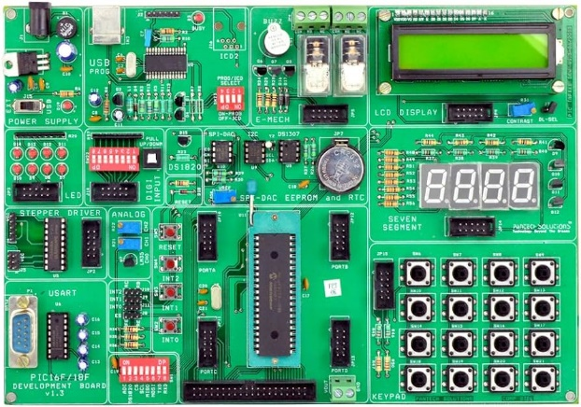

Figure PIC 16F887

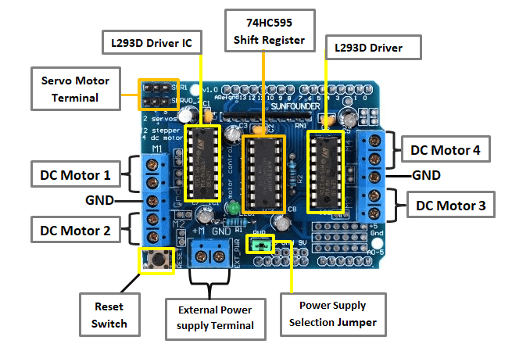

Figure DC Motor Driver

*B. DC Motor Driver*

The L293D is a dedicated module to fit in Arduino UNO R3 Board, and Arduino MEGA. It is actually a motor driver shield that has full featured Arduino Shield can be used to drive 2 to 6 DC motor and 4 wire Stepper motor and it has 2 set of pins to drive a SERVO.L203D is a monolithic integrated that has a feature to adopt high voltage, high current at four channel motor driver designed to accept load such as relays solenoids, DC Motors and Stepper Motors and switching power transistor. To simplify to used as two bridges on each pair of channels and equipped with an enable input. A separate supply input is provided for the logic, allowing operation at a lower voltage and internal clamp diodes are included. The device is suitable for use in switching applications at frequencies up to 5kHz. The L293D is assembled in a 16 lead plastic package which has 4 centre pins connected together and used for heat sinking. The L293D is assembled in a 20 lead surface mount which has 8 centre pins connected together and used for heat shrinking mount.

*C. Rotary Encoder*

A rotary encoder, also called a shaft encoder shown in figure 3, is an electro-mechanical device that converts the angular position or motion of a shaft or axle to an analog or digital output signals. An incremental rotary encoder can measures distance, speed & position. Rotary encoders are used in a wide range of applications that require monitoring or control, or both, of mechanical systems, including industrial controls, robotics, photographic lenses, computer input devices such as optomechanical mice and trackballs, controlled stress rheometers, and rotating radar platforms.

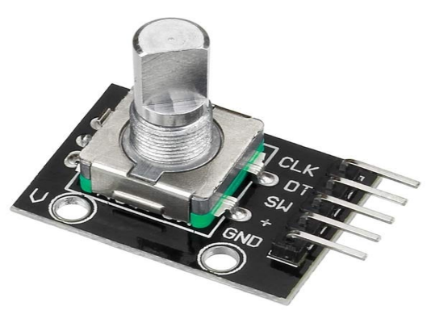

Figure Rotary Encoder

*D. DC Motor*

A DC motor is an [electrical motor](https://en.wikipedia.org/wiki/Electrical_motor) that uses direct current (DC) to produce mechanical force depicted in figure 4. The most common types rely on magnetic forces produced by currents in the coils. Nearly all types of DC motors have some internal mechanism, either electromechanical or electronic, to periodically change the direction of current in part of the motor.DC motors were the first form of motors widely used, as they could be powered from existing direct-current lighting power distribution systems. A DC motor's speed can be controlled over a wide range, using either a variable supply voltage or by changing the strength of current in its field windings. Small DC motors are used in tools, toys, and appliances. The [universal motor](https://en.wikipedia.org/wiki/Universal_motor), a lightweight [brushed](https://en.wikipedia.org/wiki/Brush_(electric)) motor used for portable power tools and appliances can operate on direct current and alternating current. Larger DC motors are currently used in propulsion of electric vehicles, elevator and hoists, and in drives for steel rolling mills. The advent of [power electronics](https://en.wikipedia.org/wiki/Power_electronics) has made replacement of DC motors with [AC motors](https://en.wikipedia.org/wiki/AC_motors) possible in many applications.

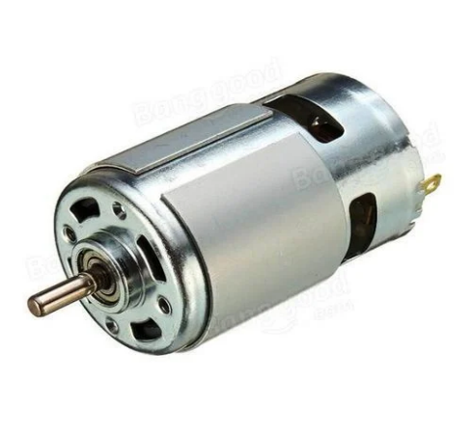

Figure DC Motor

*E. Battery*

An electric battery is a source of [electric power](https://en.wikipedia.org/wiki/Electric_power) consisting of one or more [electrochemical cells](https://en.wikipedia.org/wiki/Electrochemical_cell) with external connectionsfor powering [electrical](https://en.wikipedia.org/wiki/Electricity) devices. When a battery is supplying power, its positive terminal is the [cathode](https://en.wikipedia.org/wiki/Cathode) and its negative terminal is the [anode](https://en.wikipedia.org/wiki/Anode). The terminal marked negative is the source of electrons that will flow through an external electric circuit to the positive terminal. When a battery is connected to an external electric load, a [redox](https://en.wikipedia.org/wiki/Redox) reaction converts high-energy reactants to lower-energy products, and the [free-energy](https://en.wikipedia.org/wiki/Gibbs_free_energy) difference is delivered to the external circuit as electrical energy. It is given in figure 5. Historically the term "battery" specifically referred to a device composed of multiple cells; however, the usage has evolved to include devices composed of a single cell.

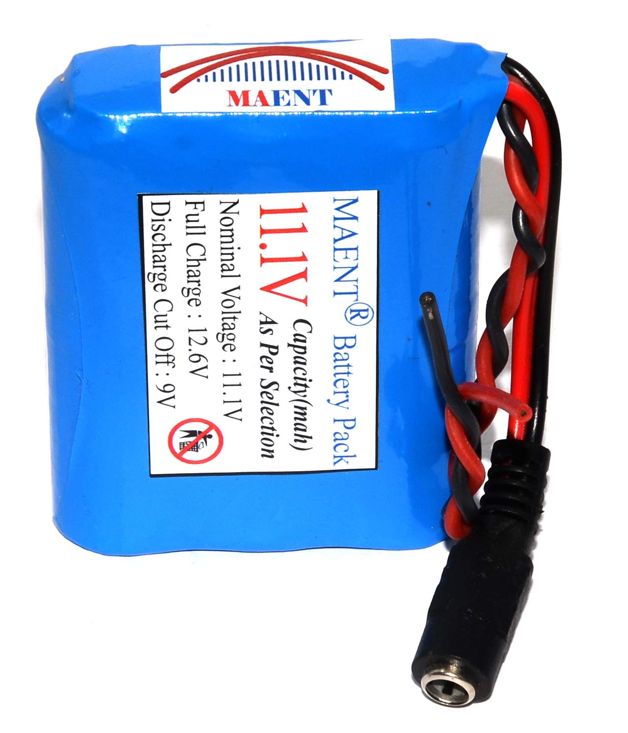

Figure Battery

# BLOCK DIAGRAM

The block diagram for the automatic line marking system is depicted in figure 6. It involves PIC Microcontroller, DC Motor Driver, Rotary Encoder and DC Motor.

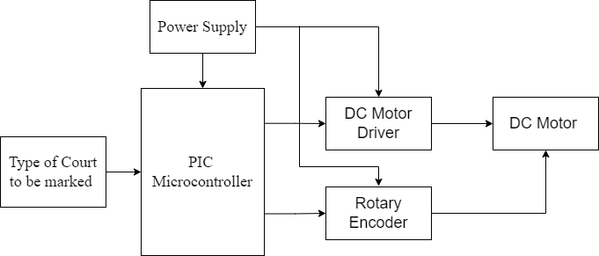

Figure Block Diagram

# RESULTS AND DISCUSSION

The Line Marking Robot project successfully integrates several key components, including a PIC microcontroller and a DC motor driver, to develop a robust automated system for marking lines on various types of sports courts. This innovative system replaces the labor-intensive and time-consuming manual methods traditionally used in court marking, bringing significant improvements in precision, efficiency, and ease of use. The prototype is depicted in figure 7. The core of the system is the PIC microcontroller, programmed to handle specific requirements for different sports courts. Users can select the desired court type through a user-friendly interface, which the microcontroller interprets to determine the necessary measurements and patterns. The robot autonomously navigates the court using advanced algorithms and sensors, including rotary encoders, to ensure real-time positional feedback and precise control over its movements. It dispenses limestone powder from the back, ensuring straight and even lines, similar to drawing with chalk but without manual intervention. Limestone is used to mark the Handball court which is depicted in Figure 8. For permanent markings, the robot can switch to dispensing paint, providing flexibility based on user needs. The project significantly reduces the time required for marking courts, completing the task in under 30 minutes compared to the 2-3 hours typically needed by manual methods. This efficiency saves time, reduces labor costs, and minimizes court downtime. The robot's high precision, achieved through rotary encoders and real-time feedback, ensures consistently accurate markings, crucial for sports where exact measurements are essential. Flexibility is another advantage, with the robot able to switch between marking substances and accommodate specific court dimensions. User feedback has been overwhelmingly positive, highlighting ease of operation, customization options, and consistent, high-quality results. Overall, the line marking robot represents a significant advancement in sports and recreational facility maintenance, setting a new standard with its combination of precision, efficiency, flexibility, and user satisfaction.

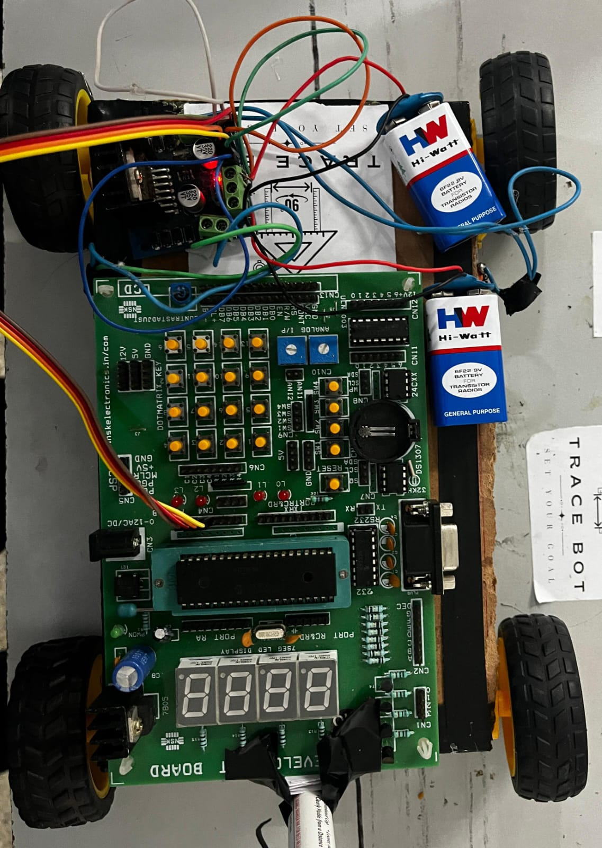

Figure Prototype image

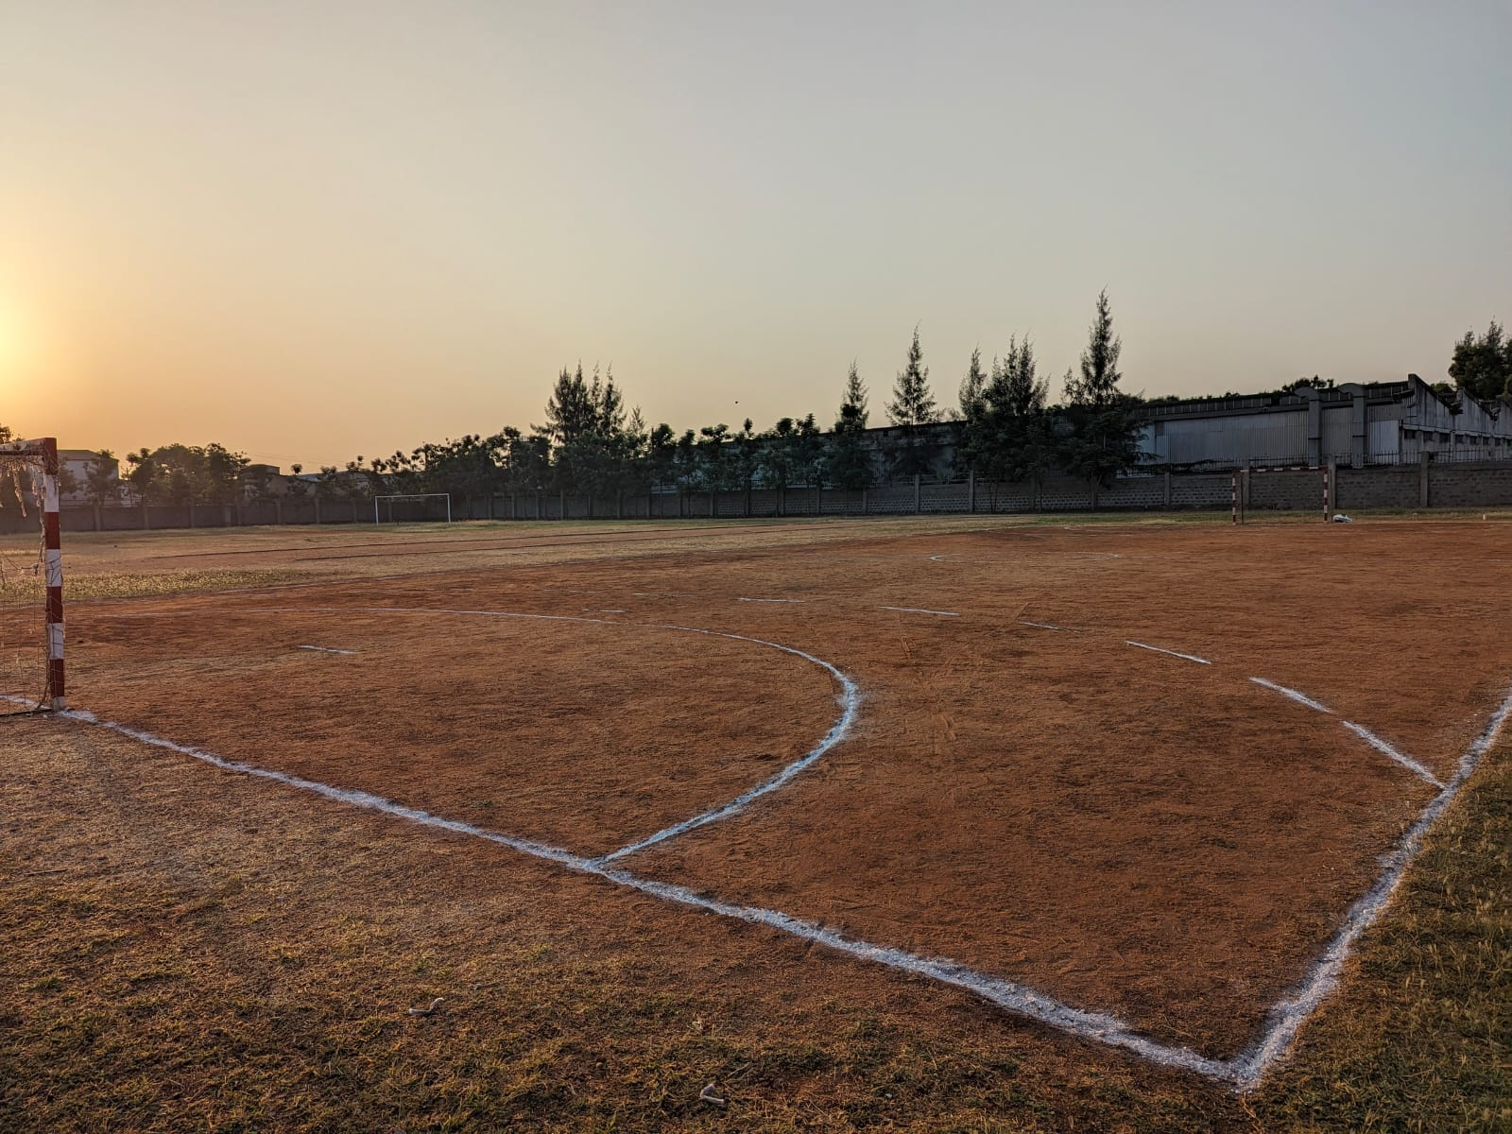

Figure Court marked by our robot

# CONCLUSION

Our line marking robot represents a successful integration of mechanical engineering, electronics, and software programming to automate the task of marking lines on sports courts and other surfaces. By utilizing a combination of DC motors, a PIC microcontroller, and a rotary encoder, we have achieved precise and accurate line marking, tailored to the specific dimensions required for each game or sport. The incorporation of user inputs for court dimensions ensures flexibility and adaptability, allowing the robot to mark lines according to varying requirements. Additionally, the implementation of algorithms for navigation and maneuverability enables the robot to navigate smoothly around obstacles and execute precise turns, further enhancing its efficiency and effectiveness in the field. Overall, our line marking robot offers a reliable solution for stadium maintenance and sports facility management, streamlining the process of line marking and contributing to the upkeep of sporting venues. Its automated capabilities reduce the need for manual labor, saving time and resources while ensuring consistent and professional results.

REFERENCES

[1] Hidayat, Muhammad, Anisah Ulfah Fauziyya, and Syahril Ardi. "Design control system of arm robot for loading and unloading part on marking machine in automotive manufacturing industry." In AIP Conference Proceedings, vol. 2114, no. 1. AIP Publishing, 2019.

[2] Khan, B. S., M. Hanafi, and S. Mashohor. "Automated road marking detection system for autonomous car." In 2015 IEEE Student Conference on Research and Development (SCOReD), pp. 398-401. IEEE, 2015.

[3] Morrissett, Adam, and Sherif Abdelwahed. "A review of non-lane road marking detection and recognition." In 2020 IEEE 23rd International Conference on Intelligent Transportation Systems (ITSC), pp. 1-7. IEEE, 2020.

[4]Zhao, Kun, Mirko Meuter, Christian Nunn, Dennis Müller, Stefan Müller-Schneiders, and Josef Pauli. "A novel multi-lane detection and tracking system." In 2012 IEEE Intelligent Vehicles Symposium, pp. 1084-1089. IEEE, 2012.

[5]Hameed, Ibrahim A., Claus G. Sorrenson, Dionysis Bochtis, and Ole Green. "Field robotics in sports: automatic generation of guidance lines for automatic grass cutting, striping and pitch marking of football playing fields." International Journal of Advanced Robotic Systems 8, no. 1 (2011): 10.

[6]Hameed, Ibrahim A. "Path planning for line marking robots using 2D Dubins’ path." In Proceedings of the International Conference on Advanced Intelligent Systems and Informatics 2016 2, pp. 900-910. Springer International Publishing, 2017.

[7]Mohd Kiblee, Shahizul Eza. "Lane detection system for autonomous vehicle using image processing techniques." PhD diss., Universiti Putra Malaysia, 2005.

[8]M. A. H. Ali, W. A. B. W. Yusoff, Z. B. Hamedon, Z. B. M. Yussof and M. Mailah, "Mechatronic design and development of an autonomous mobile robotics system for road marks painting," 2016 IEEE Industrial Electronics and Applications Conference (IEA Con), Kota Kinabalu, 2016, pp. 336-341.

[9]S. Ohno and T. Takimoto, "Development of the Automatic Line Maker Bobot by the Laser Telemeter," 2018 18th International Conference on Control, Automation and Systems (ICCAS), Daegwallyeong, 2018, pp. 150-155.1.

[10]S. Kotani, S. Yasutomi, X. Kin, H. Mori, S. Shigihara and Y. Matsumuro, "Image processing and motion control of a lane mark drawing robot," Proceedings of 1993 IEEE/RSJ International Conference on Intelligent Robots and Systems (IROS '93), Yokohama, Japan, 1993, pp. 1035-1041 vol.2.